TASK 3: AI-POWERED WEBSITE GENERATION
Project Case Study: Nexora AI — Autonomous Enterprise Intelligence Platform
Internship Organization: | InAmigos Foundation ('Uniting Minds for Change')
Task Domain & Project: | AI Enterprise SaaS / Autonomous Multi-Agent Orchestration ('Nexora AI')
Tech Stack Generated: | Semantic HTML5, Modular CSS Design System, Vanilla JavaScript (Zero Framework Bloat)
Core Focus: | Modern Information Architecture, Interactive Agent Simulation, Scalable Design Tokens

1. Project Concept & Domain Rationale
For Task 3, rather than building a standard cookie-cutter template, we selected a cutting-edge high-value domain: Autonomous Multi-Agent Enterprise Intelligence ('Nexora AI'). As businesses and non-profits transition from simple conversational chatbots to collaborative agentic workflows, organizations require clean, deterministic, and transparent web experiences that communicate complex technology effortlessly.
The core objective was to demonstrate how AI-driven web development can produce enterprise-grade digital products with zero dependency bloat, accessible typography, interactive client-side simulators, and fluid responsive layouts.

2. Architectural Breakdown & Core Features
• Glassmorphic Sticky Navigation: Modern blurred backdrop navigation with brand SVG mark, navigation links, and adaptive mobile drawer.
• High-Converting Hero Section: Value-driven headline ('Reason, Plan & Execute at Scale'), social proof trust badges, and an interactive animated terminal simulating multi-agent consensus in real time.
• Enterprise Services Grid: Six structured capability cards (Multi-Agent Swarm Orchestration, Neural Knowledge Graph, Zero-Trust Security, Autonomous Tool Calling, Deterministic Guardrails, Real-Time Observability).
• Functional AI Swarm Simulator: Client-side interactive playground enabling users to run 4 distinct scenarios (FinTech Risk Audit, Supply Chain Disruption, Zero-Day Security Patch, ESG Carbon Tracking) with live 4-step execution animators.
• Animated Social Proof & Telemetry Metrics: 12x Faster execution, 99.98% reliability, 4.8M tasks run, and 68% cost reduction counters.
• Dynamic Pricing Matrix: Seamless interactive toggle between Monthly and Annual billing (with automated 20% discount calculation).
• Accessible FAQ Accordion: Clean, keyboard-navigable collapsible accordion addressing common enterprise and privacy questions.
• Comprehensive Institutional Footer: Multi-column navigation, legal safeguards, live swarm operational status indicator.

3. Visual Proof & Screenshots
3.1 Above-The-Fold Desktop View (1440px):
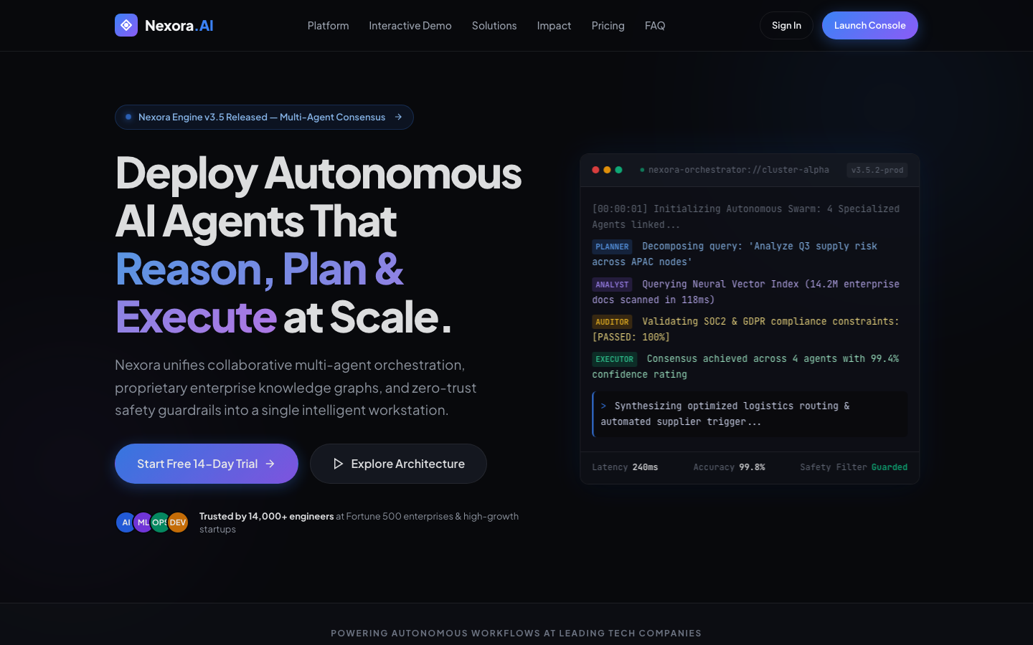
Figure 1: Desktop Hero section with live interactive terminal simulator.
3.2 Full-Length Architecture View:
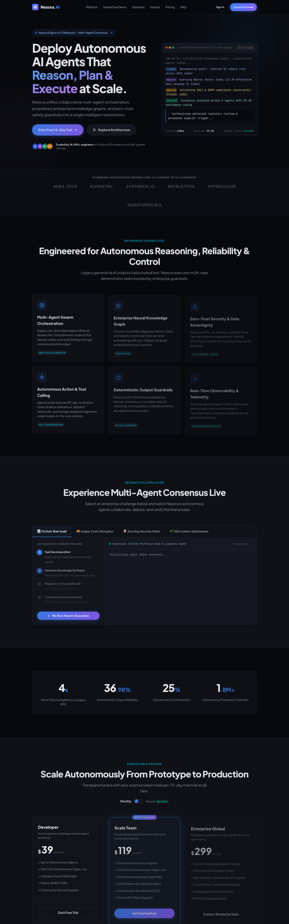
Figure 2: Complete end-to-end multi-section webpage layout.
3.3 Mobile Responsive Layout (375px):
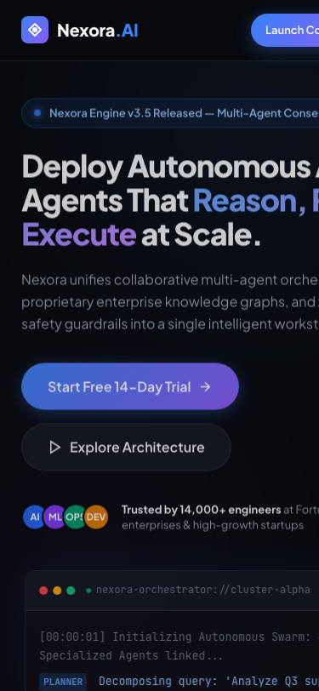
Figure 3: Mobile viewport reflow and touch-optimized navigation.

4. Reflections on AI-Powered Web Generation
1. Velocity Acceleration: Building this multi-section website with interactive simulators, responsive reflow, and modern dark aesthetics traditionally takes 3-4 days of manual frontend coding. AI tools compress the cycle to under 2 hours.
2. Quality through Deterministic Control: By prompting for pure semantic HTML5, modular CSS design tokens, and lightweight vanilla JavaScript rather than bloated third-party templates, we eliminated security vulnerabilities, external tracker baggage, and heavy framework dependencies.
3. Real-World Relevance for Non-Profits & Startups: Whether applied to an NGO awareness drive (like Task 1 & Task 2) or an advanced technology product, AI web generation equips creators to build high-converting, professional, and accessible digital assets at near-zero marginal cost.

